Uploading Input File

1. **Use Case Flow**

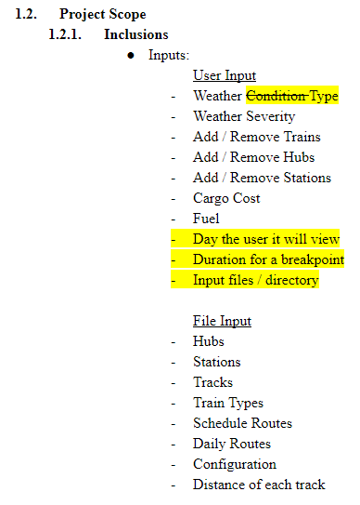

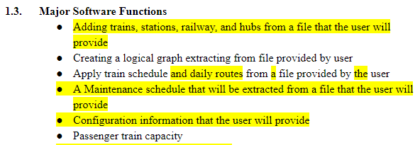

1. **Use Case Diagram**

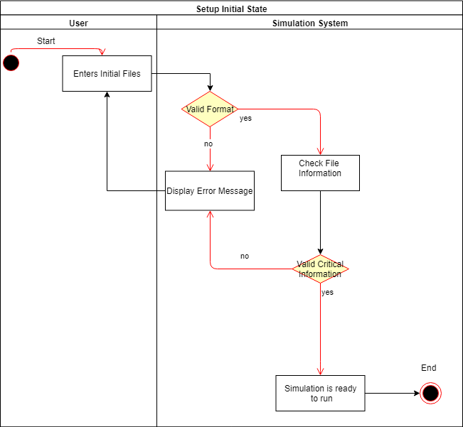

1. **ERD**

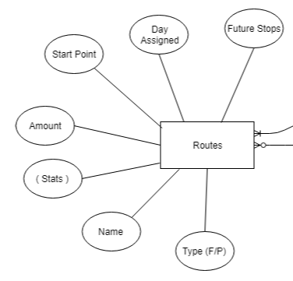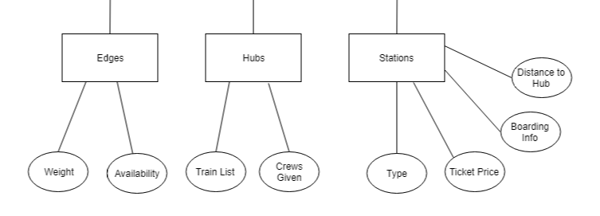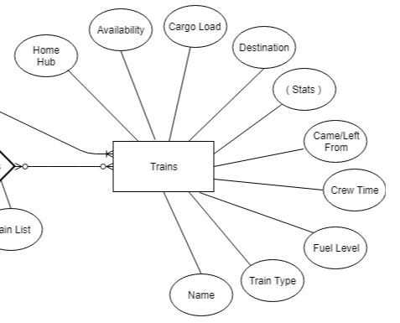

1. **DFD**

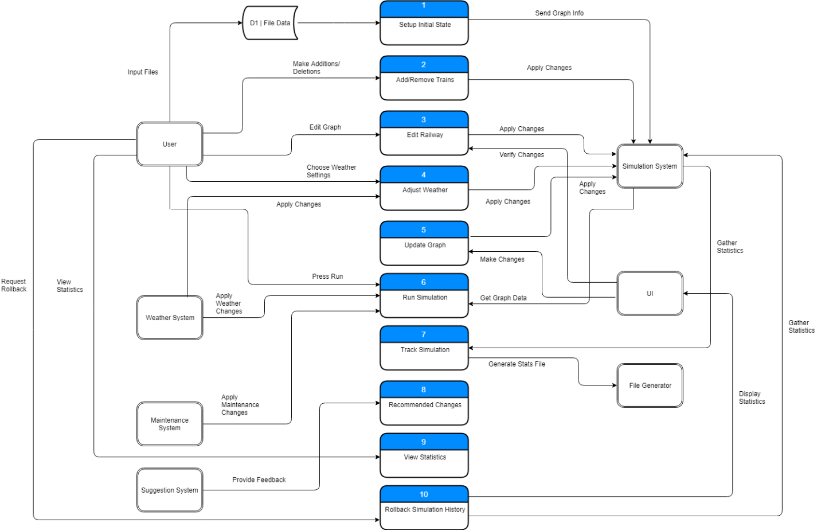

1. **Communication Diagram**

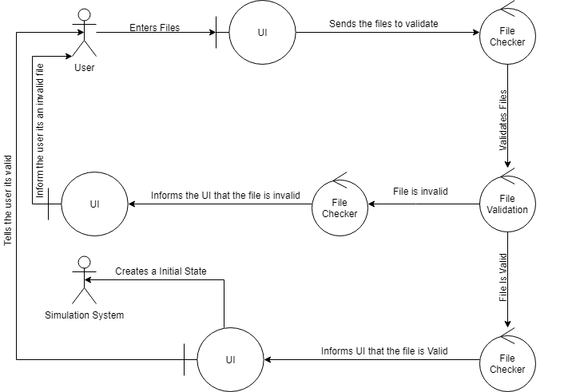

1. **CRC Card**

|  |  |
| --- | --- |
| **Class: Input Files** | |
| Description: User inputs files: Control, Maintenance, Config, Repeat Routes, & Daily Routes | |
| Class Type: Control | |
| **Responsibility** | **Collaborators** |
| Find and process data from files | Simulation |
| Apply data to graph/simulation | File Verification |
| Return errors if incorrect format found | UI |
|  |  |

1. **Class Diagram**

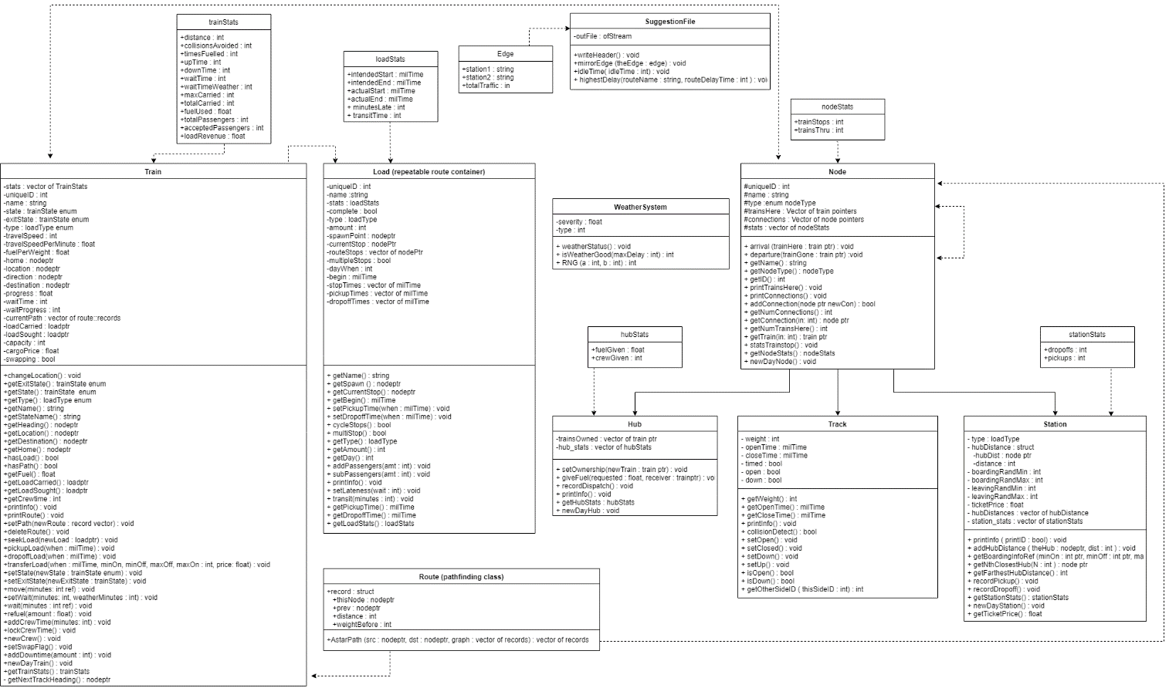

1. **Architecture Diagram**

N/A

1. **Algorithm**

- Screenshots included are snippits from longer algorithm file, can be found in misc upload file

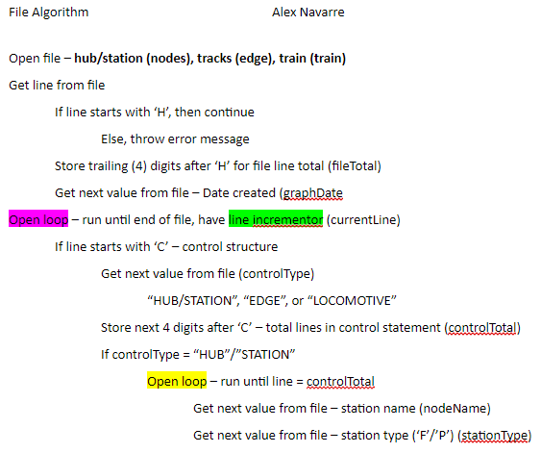

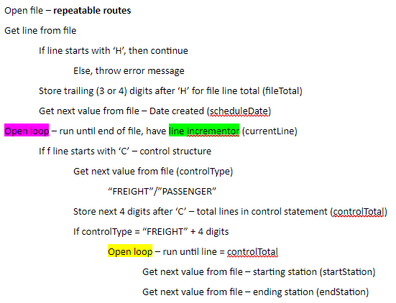

1. **Sequence Diagram**

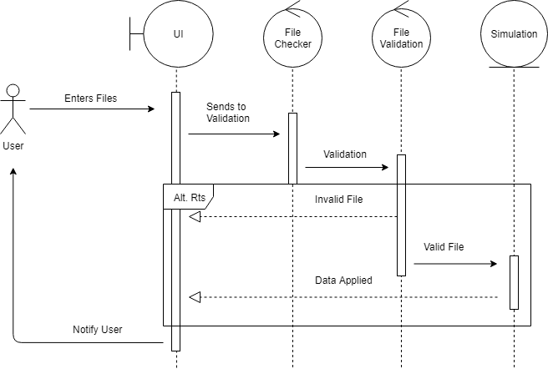

1. **Code**

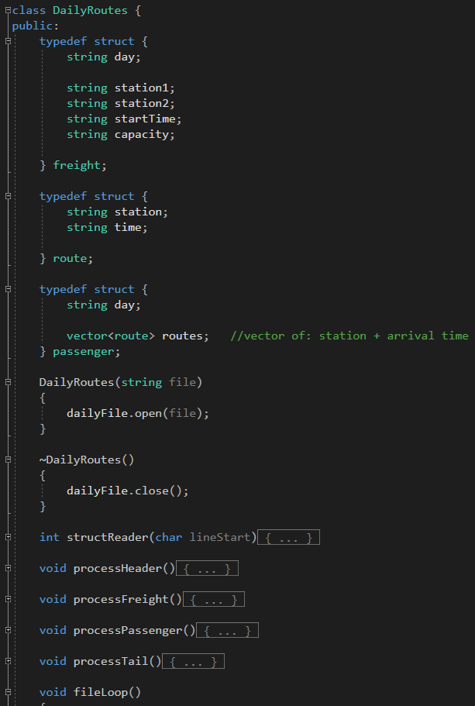

1. **Execution**

